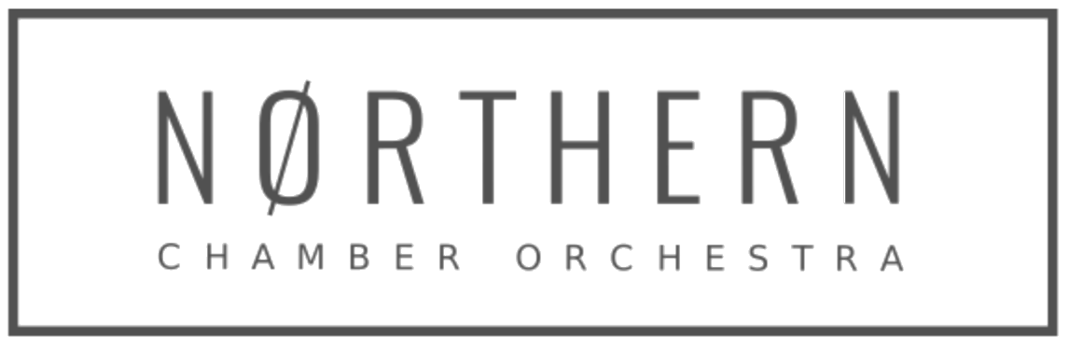

**Job Description / Person Specification: Finance and Administration Officer**

**Part-time: 24 hours per week** to include attendance at 8 weekend concerts.

Formed in 1967 and based in Manchester, the Northern Chamber Orchestra is the region’s longest-established professional chamber ensemble. Described as being ‘Simply world-class’ by Opera Magazine, the orchestra presents an annual series of concerts across the North of England, which attract acclaimed soloists, and is engaged by festivals, choirs and event promoters. The orchestra, a registered charity, also delivers a range of community and participatory opportunities for all ages.

**Purpose of the Job:**

To maintain financial and administrative records and systems to ensure the efficient running of the business and ensure legal compliance.

**Responsible to:** Chief Executive

**Works with:** Marketing Officer and freelance Orchestra Player-Member musicians, Orchestra Fixer, Concerts Manager, Librarian and Education Co-Ordinator.

**Based:** The Orchestra operates largely remotely but meets one day a week based at a co-working space at Withington Baths <https://withingtonbaths.com/withington-works/>. The role will involve remote working with one day a week joint working (with Chief Executive and Marketing Officer). Plus concert front-of-house support as below. Working pattern flexibly to be agreed with Chief Executive.

**Main Duties**

We are seeking an organised and flexible professional with an extensive range of administrative skills who will undertake:

* Oversee all book-keeping and financial administration tasks using the Xero platform and online banking facility
* Reconcile all financial transactions in order to prepare VAT returns, monthly P&L report, monthly management accounts, bank reconciliation, credit control etc
* Process all payments including player payments and suppliers and provide remittances.
* Prepare the annual Orchestral Tax Relief submission including compiling all figures and completing the official template following HMRC guidance (training will be provided)
* Prepare the annual Gift Aid and PRS submissions.
* Prepare the annual accounts for review from the company Accountant
* Provide monthly reports to Finance Director
* Ensure all statutory finance requirements are met for NCO as charity and limited company such including submissions to HMRC, Companies House and The Charity Commission
* Coordinate office administration including concert ticket processing, diary management, stocking office supplies and stationery etc.
* Deal with calls and enquiries through the organisation’s Box Office & Information Line and manage ticket sales including season tickets.
* Support the Chief Executive with administration of NCO’s Patrons’ Scheme and Board matters
* Provide the Marketing Officer with occasional marketing support such as mailshots, mailing lists and research and season ticket renewals and mailout.
* Provide front-of-house support at NCO-promoted concerts, including: supervising fire stewards / ticket and programme sellers; overseeing the bar setup and service; administering concert ‘check-lists’. 8 Saturdays per year in Macclesfield (currently Kings School and St Michael’s Church) and the second Friday in December at Tatton Park.
* Coordinate and contribute to team meetings and sub-committee meetings, as appropriate, including producing Board papers and produce Board meeting (by Zoom) minutes.
* Undertake other duties as required in support of the NCO management team, as requested by the Chief Executive.

If and when duties and responsibilities change, the Job Description will be reviewed and amended in consultation with the post holder.

**Person Specification: Skills, Aptitude and Experience**

**Essential:**

* Highly organised with strong communication skills. Comfortable dealing with a wide range of people on the phone, in person or via email.
* Experience and/or proficiency in book-keeping or a finance role, using finance software packages. Knowledge of Xero software preferred.
* Excellent time-management skills
* Ability to prioritise, work to deadlines and cope well with the challenges of working in a busy office environment.
* Enthusiastic team player, able to recognise when to consult with others, and with the ability and confidence to work independently.
* Good numeracy and writing skills, with excellent attention to detail and accurate spelling and grammar.
* High level of computer literacy, with proficiency in Microsoft Office packages particularly Outlook, Word and Excel.
* Availability to staff weekend/evening NCO concerts (generally in Macclesfield).
* Reliable home broadband connection.

**Desirable:**

* Knowledge of working in an arts or charity environment.
* Knowledge of and / or enthusiasm for classical music.
* Possession of a valid, UK driver’s license.

**The role is for 24 hours per week (equivalent three days) £****15,688 plus NEST Pension**. We aim to be flexible - working pattern to be discussed but this is a hybrid role of part remote/part office based. When working at NCO-promoted concerts TOIL will apply.

For more information please email [admin@ncorch.co.uk](mailto:admin@ncorch.co.uk) or phone 07769 368312. More details can be found at www.ncorch.co.uk

The NCO is striving to be an equal opportunities employer.

**Apply** on the application form only to [admin@ncorch.co.uk](mailto:admin@ncorch.co.uk) marking your application *‘Finance & Administration Application*’ in the subject line. CVs will not be accepted