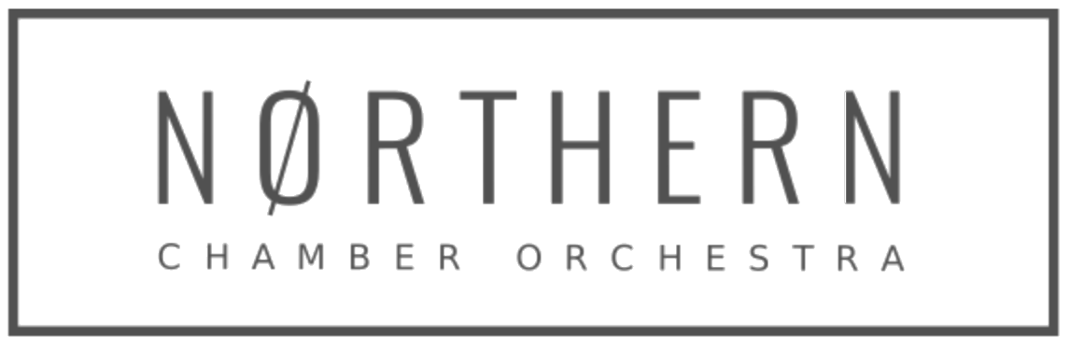

Job Description / Personal Specification: Finance and Administration Officer
Part-time: 24 hours per week including attendance at weekend concerts.

Formed in 1967 and based in Manchester, the Northern Chamber Orchestra is one of the country’s top professional chamber orchestras, with its concerts and recordings warmly received by critics. The members of the NCO are distinguished chamber musicians who regularly appear as soloists. Described as being ‘Simply world-class’ by Opera Magazine, the orchestra presents an annual series of concerts across the North of England, which attract acclaimed soloists, and is engaged by festivals, choirs and event promoters. The orchestra, a registered charity, also delivers a range of learning and development opportunities for all ages.

Purpose of the Job:
To maintain financial and administrative records and systems to ensure the efficient running of the business and ensure full legal compliance.

Responsible to: Chief Executive
Works with: Marketing Manager and freelance Orchestra Player-Member musicians, Orchestra Fixer, Concerts Manager, Librarian and Education Co-Ordinator.

Based: The Orchestra is currently looking for new office premises. The role will initially involve remote working with one day a week joint working (with Chief Executive and Marketing Manager) at a shared space tbc in Manchester. Plus concert front-of-house support as below. Working pattern to be agreed with Chief Executive.

Main Duties
We are seeking a highly organised and flexible professional with an extensive range of administrative skills who will undertake:

- Oversee all book-keeping and financial administration tasks using the Xero platform and online banking facility
- Input all financial transactions in order to prepare VAT returns, monthly P&L report, monthly management accounts, bank reconciliation, credit control etc
- Oversee the monthly payroll processing and HMRC/pensions filings
- Prepare the annual Orchestral Tax Relief submission following HMRC guidance
- Prepare the annual accounts for review from the company Accountant
- Ensure all statutory finance requirements are met for NCO as charity and limited company such including submissions to HMRC, Companies House and The Charity Commission
- Coordinate office administration including concert ticket processing, stocking office supplies and stationery etc.
- Deal with calls and enquiries through the organisation’s Box Office & Information Line and manage ticket sales including season tickets.
- Support the General Manager with administration of NCO’s Patrons’ Scheme and Board matters
- Provide the Marketing Manager with occasional marketing support such as mailshots, mailing lists and research
- Provide front-of-house support at NCO-promoted concerts, including: supervising fire stewards / ticket and programme sellers; overseeing the bar setup and service; administering concert ‘check-lists’. 8 Saturdays per year in Macclesfield (currently Kings School and St Michael’s Church) and the second Friday in December at Tatton Park.
- Coordinate and contribute to team meetings and sub-committee meetings, as appropriate, including producing Board papers and produce Board meeting minutes.
- Undertake other duties as required in support of the NCO management team, as requested by the General Manager.

If and when duties and responsibilities change, the Job Description will be reviewed and amended in consultation with the post holder.

Person Specification: Skills, Aptitude and Experience

Essential:
- Highly organised with strong communication skills. Comfortable dealing with a wide range of people on the phone, in person or via email.
- Experience and/or proficiency in book-keeping or a finance role, using finance software packages
- Excellent time-management skills
- Ability to prioritise, work to deadlines and cope well with the challenges of working in a busy office environment.
- Enthusiastic team player, able to recognise when to consult with others, and with the ability and confidence to work independently.
- Good numeracy and writing skills, with excellent attention to detail and accurate spelling and grammar.
- High level of computer literacy, with proficiency in Microsoft Office packages particularly Outlook, Word and Excel.
- Availability to staff weekend/evening NCO concerts (generally in Macclesfield) and very occasional evening meetings.
- Reliable home broadband connection and own laptop

Desirable:
- Knowledge of working in an arts or charity environment.
- Knowledge of and / or enthusiasm for classical music.
- Possession of a valid, UK driver’s license.

The role is for 24 hours per week (equivalent three days) £14,214. We aim to be flexible - working pattern to be discussed but this is a hybrid role of part remote/part office based. When working at NCO-promoted concerts TOIL will apply.

For more information please email charlie@ncorch.co.uk or phone 07769 221957. More details can be found at www.ncorch.co.uk

The NCO is striving to be an equal opportunities employer.

Apply on the application form only to charlie@ncorch.co.uk marking your application ‘Finance & Administration Application’ in the subject line. CVs will not be accepted

