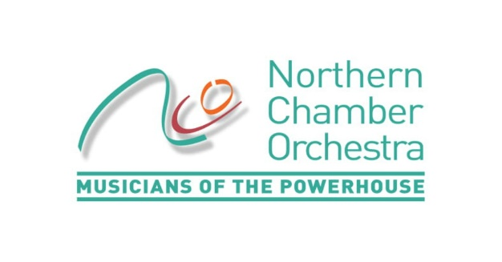

Job Description / Personal Specification: Finance and Administration Officer
Part-time: 24 hours per week including attendance at occasional evening concerts.

Formed in 1967 and based in Manchester, the Northern Chamber Orchestra is one of the country’s top professional chamber orchestras, with its concerts and recordings warmly received by critics. The members of the NCO are distinguished chamber musicians who regularly appear as soloists. Described as being ‘Simply world-class’ by Opera Magazine, the orchestra presents an annual series of concerts across the North of England, which attract acclaimed soloists, and is engaged by festivals, choirs and event promoters. The orchestra, a registered charity, also delivers a range of learning and development opportunities for all ages.

Purpose of the Job:
To maintain financial and administrative records and systems to ensure the efficient running of the business

Responsible to: General Manager

Main Duties
We are seeking a highly organised and flexible professional with an extensive range of administrative skills who will undertake:

- Book-keeping and financial administration including invoicing, payments and banking on Sage 50 accounting package.
- Preparation of VAT returns, Monthly P&L report, bank reconciliation, credit control etc.
- Coordinate office administration – developing office systems (such as effective ways to log and extract data from sales) filing, concert ticket processing, stocking office supplies and stationery etc.
- Deal with calls and enquiries through the organisation’s Box Office & Information Line and manage ticket sales including season tickets.
- Support the General Manager with administration of NCO’s Patrons’ Scheme and Board matters.
- Provide the Marketing Manager with occasional marketing support such as mailshots, mailing lists and research
- Provide front-of-house support at NCO-promoted concerts, including: supervising fire stewards / ticket and programme sellers; overseeing CD stock control and merchandise; administering concert ‘check-lists’. Generally 8-10 per year, mostly at Macclesfield Heritage Centre
- Coordinate and contribute to team meetings and sub-committee meetings, as appropriate, and take Board meeting minutes.
- Undertake other duties as required in support of the NCO management team, as requested by the General Manager.

If and when duties and responsibilities change, the Job Description will be reviewed and amended in consultation with the post holder.

Person Specification: Skills, Aptitude and Experience

Essential:
- Highly organised with strong communication skills. Comfortable dealing with a wide range of people on the phone, in person or via email.
- Proficiency in using Sage 50 Accounting Software
- Excellent time-management skills.
- Ability to prioritise, work to deadlines and cope well with the challenges of working in a busy office environment.
- Enthusiastic team player, able to recognise when to consult with others, and with the ability and confidence to work independently.
- Good numeracy and writing skills, with excellent attention to detail and accurate spelling and grammar.
- High level of computer literacy, with proficiency in Microsoft Office packages particularly Outlook, Word and Excel.
- Availability to staff weekend/evening NCO concerts (generally in Macclesfield) and very occasional evening meetings.

Desirable:
- Knowledge of working in an arts or charity environment.
- Knowledge of and / or enthusiasm for classical music.
- Possession of a valid, UK driver’s license.

The role is for 24 hours per week (equivalent three days) £13,800- £15,000 depending upon skills and experience. To include regularly working some hours on a Friday, based in Hulme, Manchester. When working at NCO-promoted concerts TOIL will apply

The NCO is an equal opportunities employer.
For further information please email info@ncorch.co.uk or phone 0161 247 2220. More details can be found at www.ncorch.co.uk
Northern Chamber Orchestra MMU, Brooks Building, 53 Bonsall St, Hulme, Manchester M15 6GX

Apply with a cv and covering letter (no more than two sides of A4) detailing how your skills and experience make you suitable for the position to info@ncorch.co.uk marking your application ‘Finance & Administration Application’ in the subject line. Closing date: Midnight 18.09.19 Late applications will not be considered. Interviews Monday 30.09.19

